AZURE STORAGE

STORAGE OVERVIEW: Microsoft Azure storage is a Microsoft-manage cloud service that provides storage that is highly available, secure, durable, scalable and redundant. Azure storage consists four data storage: Blob storage, file storage, queue storage table storage.

On premise data storage:-

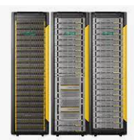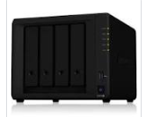

HP3 PAR Storage

NAS Storage

External harddisk

Pan Drive

Blob Storage: Azure Blob storage is a service for storage large amount of unstructured object data, such a text, binary data, that can be accessed anywhere in the world via http, https. You can use Blob storage to exposed data publicly to the world. Or to store application privately.

Containers: A container organizes a set of Blob, similar to directory in a file. A storage Account can include an unlimited number of containers, and a container can store unlimited number of blobs.

Blob Storage Max Size: **500TB**

Block Blob Max Size: **4.7TB**

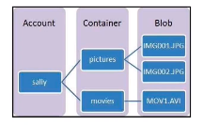

**Page Blobs store random access file up to 8TB in size. Page Blobs store virtual hard drive (VHD) file and serve as disks for Azure virtual machines**.

**Azure storage access tiers:**

**Not all data need to be stored in highest performing storage format. The cool & archive azure storage tiers available in azure storage are meant to be used to retain data that is infrequently accessed.**

Azure storage offers different access tiers, which allow you to store blob object data in the most **cost-effective manner.**

The available access tier include:

1. **HOT**- The cheapest to access, but most expensive to the store.

When be mark the storage or the blob files as Hot it means we want to these file readily accessible. The data storage in these type of storage are always readily available. In case these file are not being accessed frequently you may end up paying more than expected for the files that are not been accessed as much as it should.

**Access frequency- Higher**

**Storage cost- Higher**

**Access cost- Lower**

**2. COOL: -** Medium pries storagebut expensive to access.

We are talking about these files or storage that are not accessed frequently. Let’s taken an example of a file that summaries your system performance once a month and store it. These type of files you want to access once a while. With this type of storage you pay slightly less for storing but pay more for retrieving the file.

**Access frequency- Low**

**Storage cost- Lower**

**Access cost- Higher**

